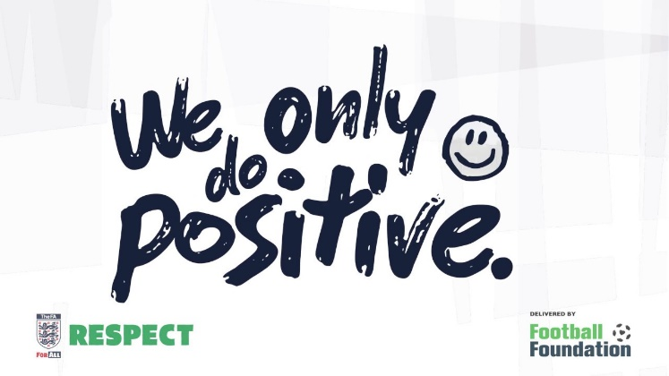
Deeping United
Code of Conduct
for players, coaches, officials and spectators

Date | Reviewed by | Approved by
1/9/2019 | E.Pearce | E.Pearce
19/5/2021 | E Pearce | E Pearce
21/6/2022 | P Utteridge | P Utteridge
04/07/2024 | E Ling | Committee (August 2024)

A Code of Conduct for Football
Football is the national game. All those involved with the game at every level whether as a player, parent, match official, coach, owner or administrator, have a responsibility, above and beyond compliance with the law, to act according to the highest standards of integrity, and to ensure that the reputation of the game is, and remains, high. This code applies to all those involved in football under the auspices of The Football Association, and specifically to our club, Deeping United.

Community
Football, at all levels, is a vital part of a community. DUFC will take into account community feeling when making decisions.
Equality
DUFC is opposed to discrimination of any form and will promote measures to prevent it, in
whatever form, from being expressed.
Participants
DUFC recognises the sense of ownership felt by those who participate at all levels of the game. This includes those who play, those who coach or help in any way, and those who officiate, as well as administrators and supporters. We are committed to appropriate consultation.
Young People
DUFC acknowledges the extent of its influence over young people and pledges to set a positive example.
Propriety
DUFC acknowledges that public confidence demands the highest standards of financial and administrative behaviour within the game, and will not tolerate corruption or improper practices.
Trust and Respect
DUFC will uphold a relationship of trust and respect between all involved in the game, whether they are individuals, clubs or other organisations.
Violence
DUFC rejects the use of violence of any nature by anyone involved in the game.
Fairness
DUFC is committed to fairness in its dealings with all involved in the game.
Integrity and Fair Play
DUFC is committed to the principle of playing to win consistent with Fair Play.

- Code of Conduct for Coaches
Coaches are key to the establishment of ethics in football. Their concept of ethics and their attitude directly effects the behaviour of players under their supervision. Coaches are, therefore, expected to pay particular care to the moral aspect of their conduct. Coaches have to be aware that almost all of their everyday decisions and choices of actions, as well as strategic targets, have ethical implications. It is natural that winning constitutes a basic concern for coaches. This code is not intended to conflict with that. However, the code calls for coaches to disassociate themselves from a “win-at-all-costs” attitude. Increased responsibility is requested from coaches involved in coaching young people. The health, safety, welfare and moral education of young people are a first priority, before the achievement or the reputation of the club, school, coach or parent. Set out below is The FA Coaches Association Code of Conduct (which reflects the standards expressed by the National Coaching Foundation and the National Association of Sports Coaches) which forms the benchmark for all involved in coaching:

- Coaches must respect the rights, dignity and worth of each and every person and treat each equally within the context of the sport.
- Coaches must place the wellbeing and safety of each player above all other considerations, including the development of performance.
- Coaches must adhere to all guidelines laid down by governing bodies.
- Coaches must develop an appropriate working relationship with each player based on mutual trust and respect.
- Coaches must not exert undue influence to obtain personal benefit or reward.
- Coaches must encourage and guide players to accept responsibility for their own behaviour and performance.
- Coaches must ensure that the activities they direct or advocate are appropriate for the age, maturity, experience and ability of players.
- Coaches should, at the outset, clarify with the players (and, where appropriate, parent) exactly what is expected of them and also what they are entitled to expect from their coach.
- Coaches must co-operate fully with other specialists (e.g. other coaches, officials, sports scientists, doctors, and physiotherapists) in the best interests of the player.
- Coaches must always promote the positive aspects of the sport (e.g. fair play) and never condone violations of the Laws of the Game, behaviour contrary to the spirit of the Laws of the Game or relevant rules and regulations or the use of prohibited substances or techniques.
- Coaches must consistently display high standards or behaviour and appearance.
- Not to use or tolerate inappropriate language.

- Code of Conduct for Players
Players are the most important people in the sport. Playing for the team, and for the team to win, is the most fundamental part of the game. But not winning at any cost – Fair Play and respect for all others in the game is fundamentally important. This Code focuses on players involved in top-class football. Nevertheless, the key concepts in the Code are valid for players at all levels.
Obligations towards the game
A player should:
- Make every effort to develop their own sporting abilities, in terms of skill, technique, tactics and stamina.
- Strive maximum effort and strive for the best possible performance during a game, even if his team is in a position where the desired result has already been achieved.
- Set a positive example for others, particularly young players and supporters.
- Avoid all forms of gamesmanship, and time wasting.
- Always have regard to the best interests of the game, including where publicly expressing an opinion on the game and any particular aspect of it, including others involved in the game.
- Not use inappropriate language.

Obligations towards one’s own team
A player should:
- Make every effort consistent with Fair Play and the Laws of the Game to help his own team win.
- Resist any influence which might, or might be seen to, bring into question his commitment to the team winning.
Respect for the Laws of the Game and competition rules
A player should:
- Know and abide by the Laws, rules and spirit of the game, and the competition rules.
- Accept success and failure, victory and defeat, equally.
- Resist any temptation to take banned substances or use banned techniques.

Respect towards Opponents
A player should:
- Treat opponents with due respect at all times, irrespective of the result of the game.
- Safeguard the physical fitness of opponents, avoid violence and rough play, and help injured opponents.

Respect towards the Match Officials
A player should:
- Accept the decision of the Match Official without protest.
- Avoid words or actions that may mislead a Match Official.
- Show due respect towards Match Officials.
Respect towards Team Officials
A player should:
- Abide by the instructions of their Coach and Team Officials, provided they do not contradict the spirit of this Code.
- Show due respect towards the Team Officials of the opposition.

Obligations towards the Supporters
A player should:
- Show due respect to the interests of supporters.

- Code of Conduct for Team Officials
This Code applies to all team / club officials (although some items may not apply to all officials).
Obligations towards the Game
The team official should:
- Set a positive example for others, particularly young players and supporters.
- Promote and develop his own team having regard to the interest of the Players, Supporters and reputation of the national game.
- Share knowledge and experience when invited to do so, taking into account the interest of the body that has requested this rather than personal interests.
- Avoid all forms of gamesmanship.
- Show due respect to Match Officials and others involved in the game.
- Always have regard to the best interests of the game, including where publicly expressing an opinion of the game and any particular aspect of it, including others involved in the game.
- Not use or tolerate inappropriate language.

Obligations towards the Team
The team official should:
- Make every effort to develop the sporting, technical and tactical levels of the club/team, and to obtain the best results by the team, using all permitted means.
- Give priority to the interests of the team over individual interests.
- Resist all illegal or unsporting influences, including banned substances and techniques.
- Promote ethical principles.
- Show due respect to the interests of players, coaches and other officials, at their own club/team and others.

Obligations towards the Supporters
The team official should:
- Show due respect to the interests of supporters.

Respect towards the Match Officials
A team official should:
- Accept the decisions of the Match Official without protest.
- Avoid words or actions that may mislead a Match Official.
- Show due respect towards Match Officials.

4)Code of Conduct for Parents / Spectators
Parents / Spectators have a great influence on children’s enjoyment and success in football. All children play football because they first and foremost love the game – it’s fun. It is important to remember that however good a child becomes at football positive encouragement will contribute to:
Children enjoying football.
A sense of personal achievement.
Self-esteem.
Assist to improve the child’s skills and techniques.
A parent’s / spectator’s expectations and attitudes have a significant bearing on a child’s attitude towards other players, their team mates, officials, coaches and spectators.
Parents / spectators are strongly encouraged to:
Applaud the opposition as well as your own team
Avoid coaching the child during the game.
Not to shout and scream.
Respect the referee’s decision.
Give attention to each of the children involved in football not just the most talented.
Give encouragement to everyone to participate in football.
Be positive and encouraging towards all of the children not just their own.

